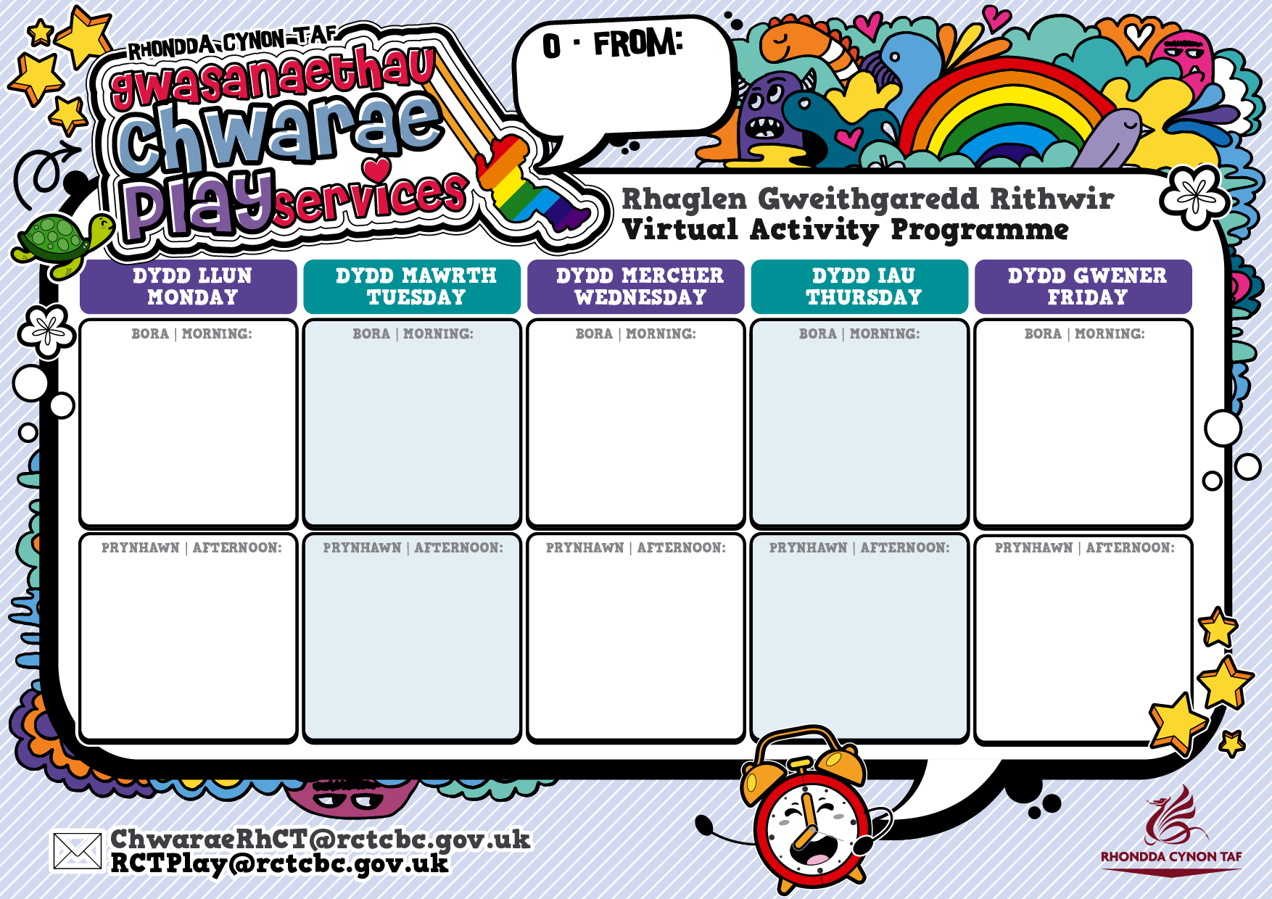

26.05.2020

**Activity**

**Bank Holiday**

**Activity**

<https://www.youtube.com/watch?v=-FiHUMMxEss>

LCDP Den Building

**Activity**

<https://www.youtube.com/watch?v=7lZnTTIRSn8>

Bryncynon Stratergy

**Activity**

<https://www.youtube.com/watch?v=lSFky71MjUE&t=13s>

How to make a fire pit Alun Hirwaun

**Activity**

<https://www.youtube.com/watch?v=725aNHDf3x0>

How to make a kite Brightleaf

**Activity**

<https://www.youtube.com/watch?v=whNGVAxT-yU>

Blaebllechau Youth Project making bug hotels

**Activity**

<https://www.youtube.com/watch?v=l7lt5k_8qvs>

Cwmparc Making Pizza

**Activity**

<https://www.youtube.com/watch?v=bMvb42v9Kvs>

Sam from Hirwaun making a Bug Hotel

**Activity**

<https://www.youtube.com/watch?v=PysqKPC4zK0>

Kirsty from RCT Play Team making Juggling Balls

**Activity**

**Bank Holiday**